**Samba server**

**What is samba server ?**

Samba is an open-source software suite that enables file and print services between Windows, Linux, and Unix systems over a network

**Linux system:**

**What should we do in both the operating system.**

**Before that we want to check firewalld and se linux services are disabled.**

* **Installing samba package.**
* **Make directory to transferring file or use already existing directory.**
* **Create a user and set samba password for that user.[]**
* **Config the file /etc/samba/smb.conf.**
* **Restart and enable the smb.service .**
* **Check whether the directory is available.**

**Windows System: run ping Linux IP**

* **Open command prompt in windows**
* **Open run by wind+r \\linux IP**
* **Enter the smb user and password**

**Linux:**

1. **Installing samba package**

**yum install samba samba-client**

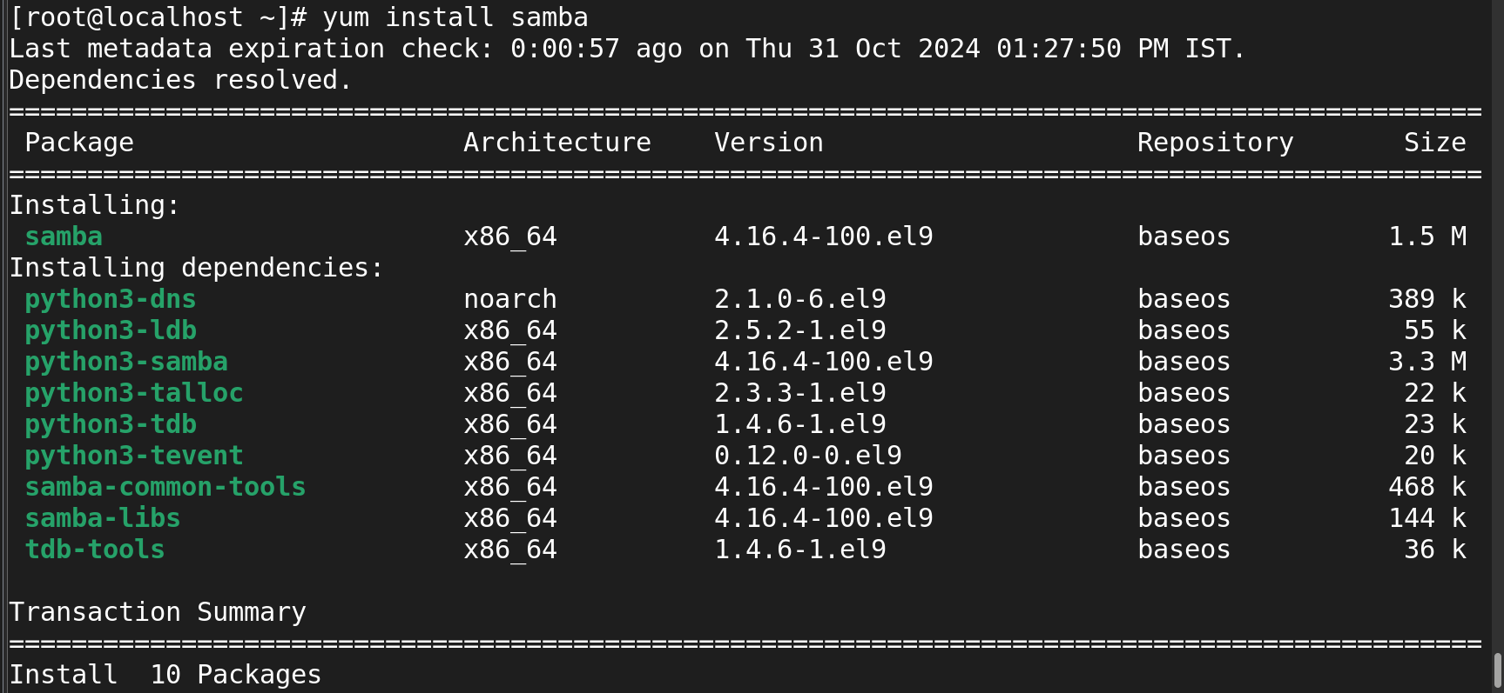

**Make directory to transferring file or use already existing directory.**

**Mkdir /games**

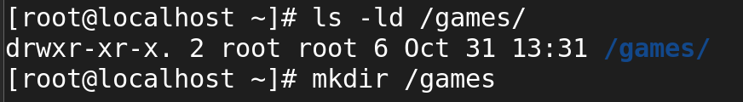

**Create a user and set samba password for that user.**

Useradd --> rocky

Smbpasswd -a --> nfs



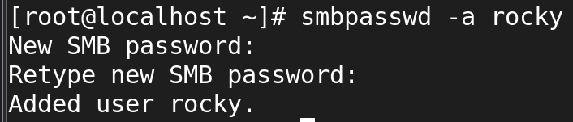

**Config the file /etc/samba/smb.conf.**

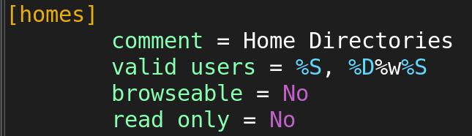

After we enterd into the above config file first we should copy the five line and paste at the below content of the config file

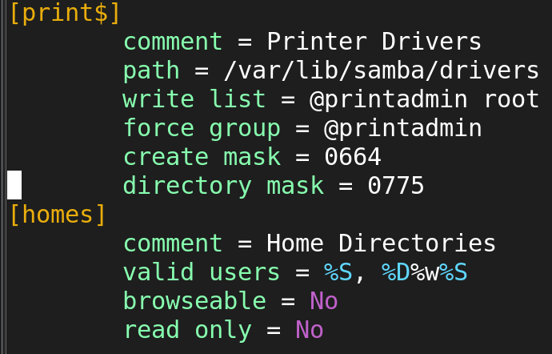

Ater the copy paste we should modify.

In the config file we should add extraley the path of the file

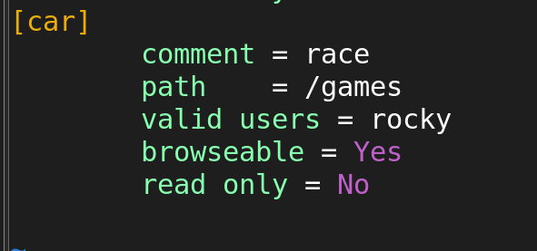

After the config file we should enable --now and as well we should restart the service after the config file.



Next step to install the samba -client to transfer the fioles and directory.

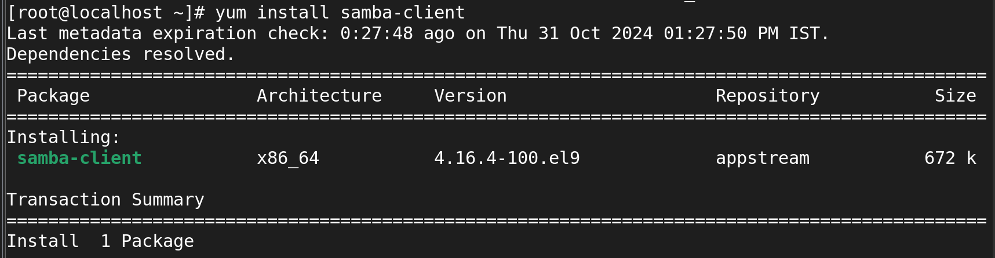

Check wheather the dir transfer to the windows system

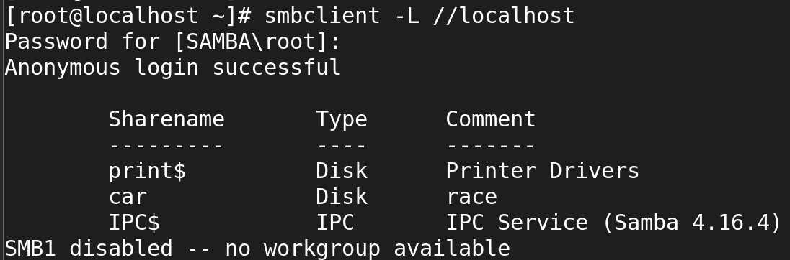

**Windows System:**

1. **Open command prompt in windows**

**Ping linux_system IP**

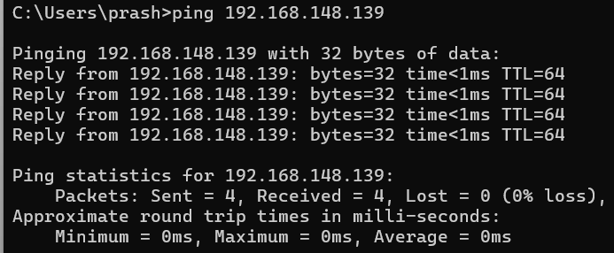

1. **Open run by wind+r**

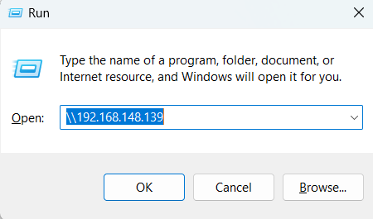

Next step to enter the username and passwd which we givee in the linux server

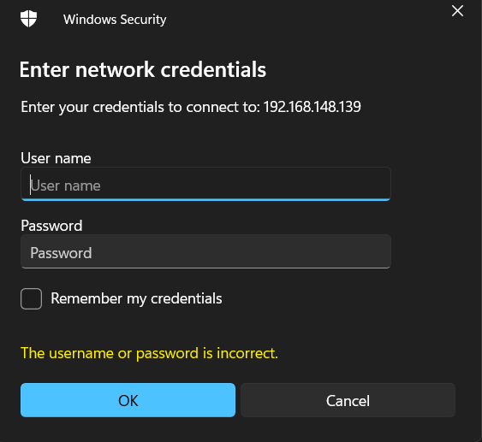

Now we switch from the linux to windows system

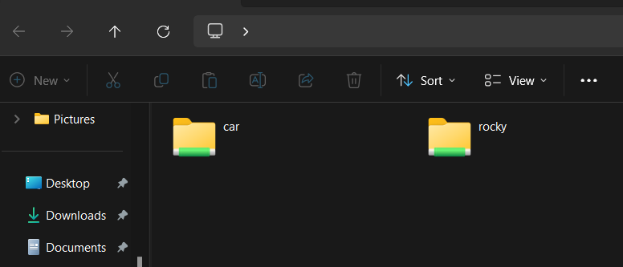

Now we create empty file in /games dirctory which we created in the linux system.

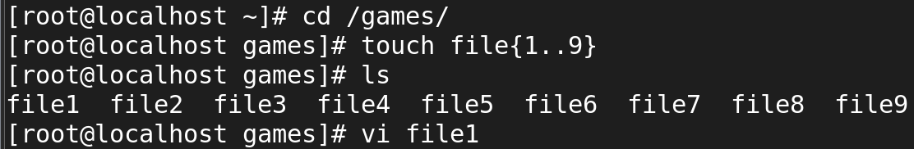

Now go and viwe the I created file in windows

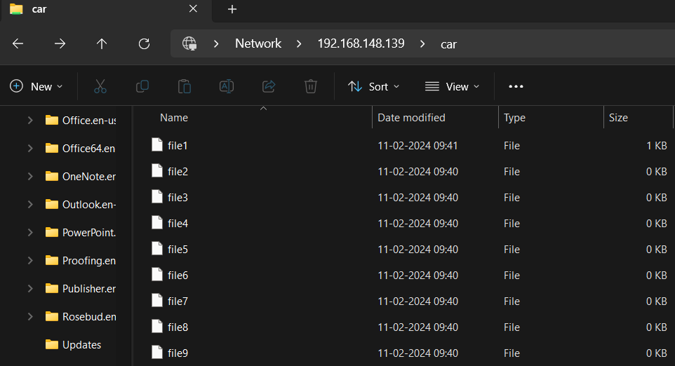

But I can’t write or create a new folder in the file it will show permission denied

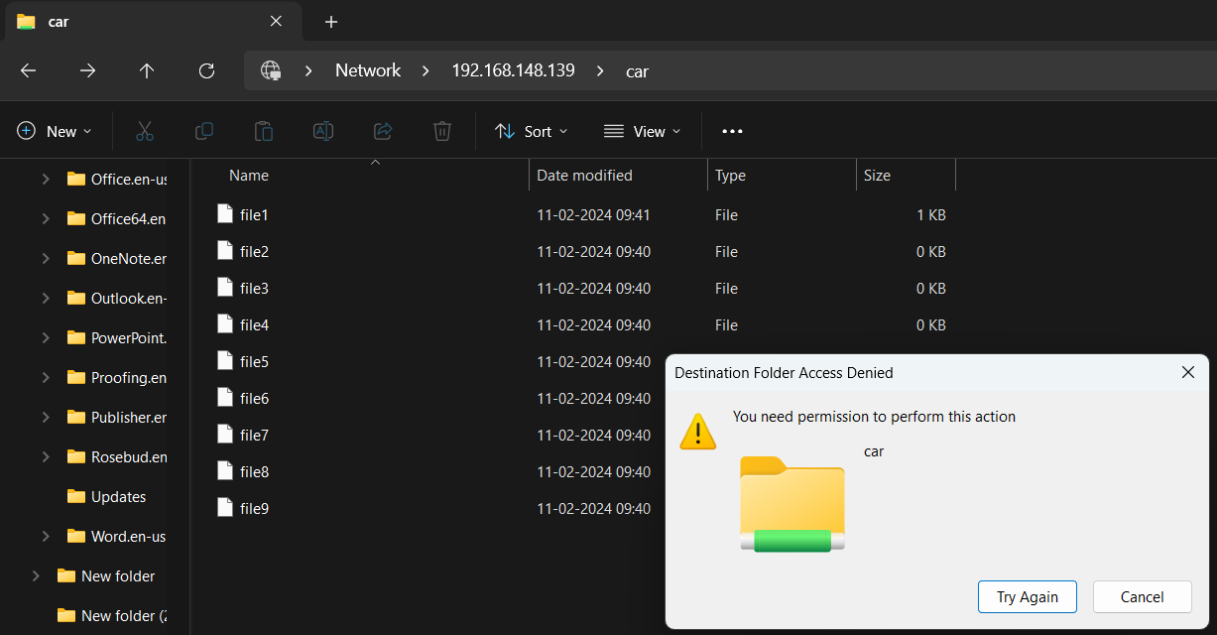

For that we should give the full permission to the /games dirctory

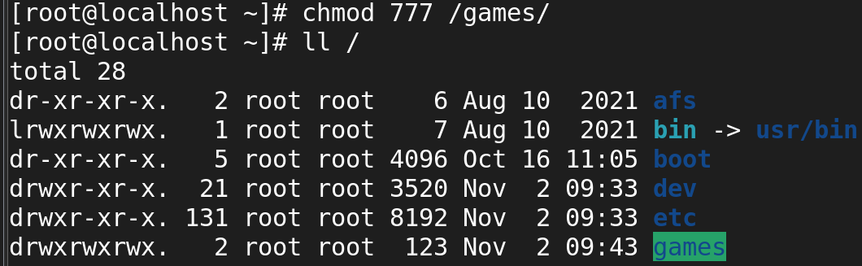

Now I can create the file.

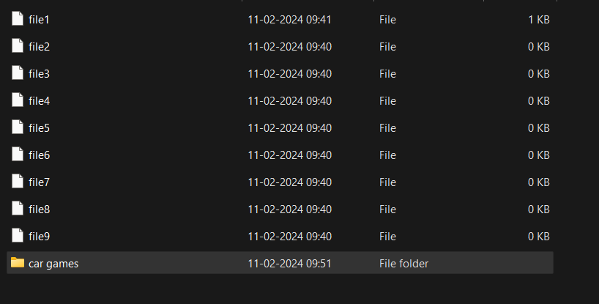

In that folder I’m transfer the photo from windows to server

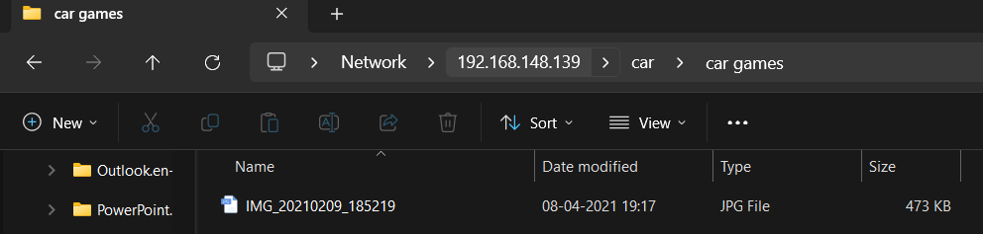

Now I viwe in linux system

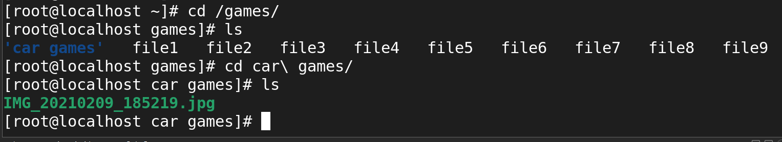

To viwe the img we use the command

eog image.jpg



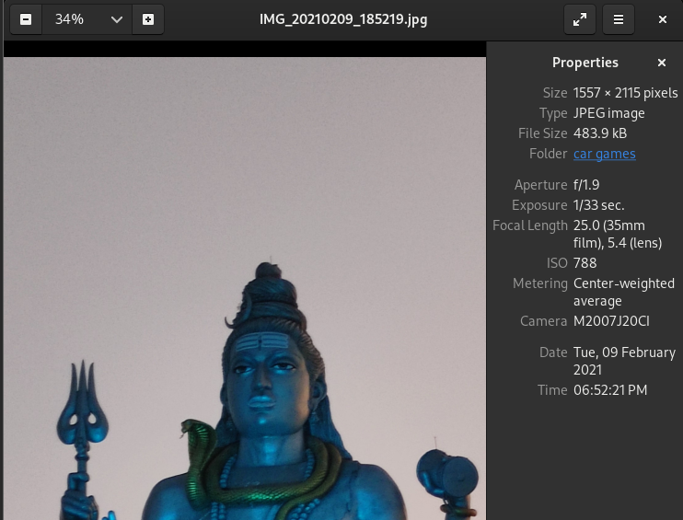

**Also I copied a picture and changed wallpaper**